Bucharest: life and pollution
Author: Irina Vîlcea , 13 years old & Iulia Avădanei, 12 years old
The seventh class
School: Şcoala Gimnazială Numărul 150, sectorul 5
City: Bucharest
Country: Romania
Teacher: Kodjabashija Corina Gabriela

Every day man pollutes the environment little by little, threatening the Planet’s and the people’s health. We decided to try to change people’s mentality, by presenting a serious problem in the city where we live, maybe even succeeding in transforming Bucharest into Romania’s or even Europe’s Green Capital.

Exhaust gases, the enemies of health
Everyone likes taking the taxi, the bus or the personal car for going to the office, at a restaurant, or to visit family members and friends.
Still, behind the comfortable seats, air conditioning and radio there are the enemies of health, the exhaust gases. These represent a major danger, containing pollutants. We haven’t thought of that while driving to grandma’s house, have we?

The carbon dioxide, the foe of the environment
Among the exhaut gases from the tailpipe there is a very dangerous one, the carbon dioxide. The percentage of carbon dioxide into the atmosphere is increasing and if the amount becomes double, the global greenhouse effect occures and it will lead to a massive chain reaction that will resoult the destruction of the Planet.

Don’t horn!
Have you ever been near a nervous, mad or hasty driver , who horns incessantly, believing that he will obtain what he wants faster? It is very unpleasant, especially if you have to stay near someone horning worse than the ambulance!
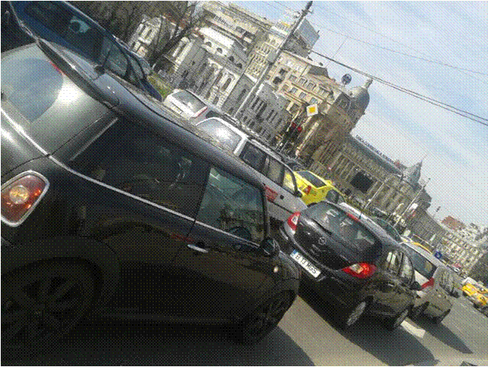The problem is that by exposing your ears for a long time to loud noises diseases like deafness and tinnitus can trigger and some of those are impossible to heal.

1.AIR AND NOISE POLLUTION

What can WE do?
Now that we found out everything about gas and diseases, it’s time to make grandmother proud and show her that we, the common people are the foundation of a GREN Capital.
Some of the solutions we had thought of are:
- Paying the RATB ticket, so the company collects enough money for buying “green cars” (electricity powered vehicles), which don’t pollute the environment. To implement this project we will have to make a petition with voluntary votes to this company, hoping to achieve our goal.
2.1. Also, we could encourage the people to confidently use scooters, bicycles, roller skates, skateboards and green cars. If they choose to use the personal car, we should advise them to take their friends or colleagues to the destination (of course, if it is the same one), for decreasing the number of cars on the streets.
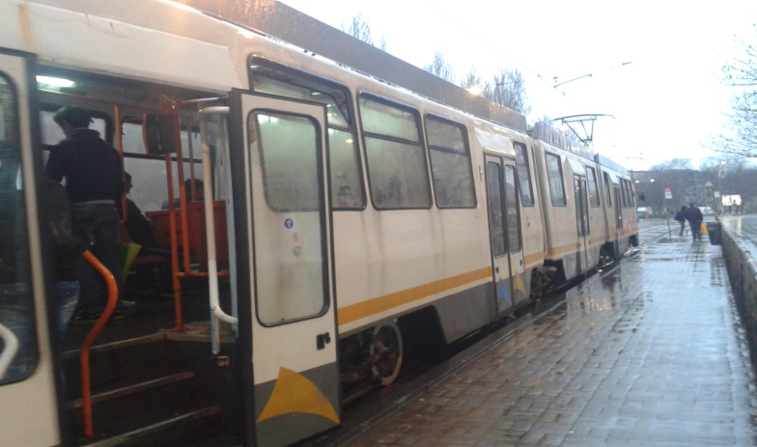
2.Using the RATB to avoid air pollution

